

**Case Management System version 1**

**May 2023**

**User Guide**

Table of Contents

Introduction 3

JRE Installation 3

Using Your New System 9

Logging In 9

Resetting Your Password 13

Adding a New Case 16

Searching 19

Viewing All Cases 21

# Introduction

This document is intended to walk you through using your shiny new software. It includes some installation guidance to help you get started and also provides some important information about using your new system.

In your User Pack you will also find a short PowerPoint presentation, called “Getting Started” that includes a few videos of how to navigate the system.

# JRE Installation

Before you can use your new system, it’s really important your equipment has the resources it needs to run on your device. Whether you are working in the office or at home, the new case management system needs a Java Runtime Environment (JRE) to be able to start. If your computer doesn’t have a JRE, you won’t be able to use the system.

A JRE provides certain tools and resources for your new system to run. You wouldn’t expect a roofer to repair a roof without a ladder. You wouldn’t expect a hairdresser to cut your hair without scissors. You wouldn’t drive a car with no tyres. They need the right tools to do the job. This is what the JRE is to your case management system.

It’s not always the case that your operating system will have a JRE installed by default. If you want to find out if you already have a JRE installed on your device, there is a short clip in your PowerPoint file that shows you how to do this. It’s quite simple: just search for “cmd” and open a Command Prompt window:

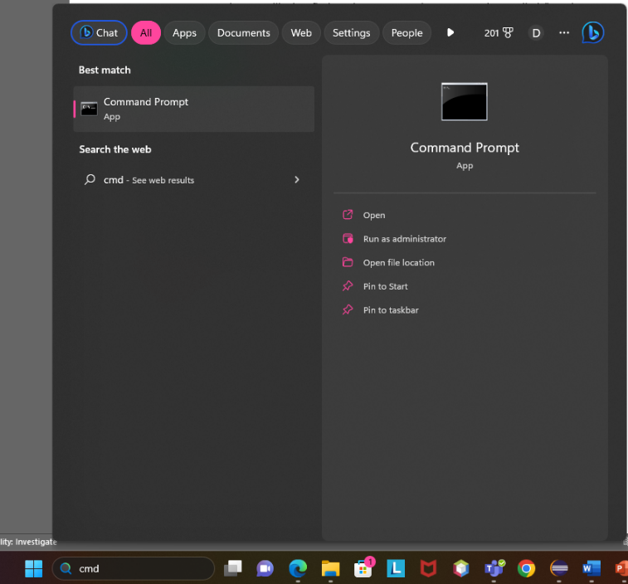

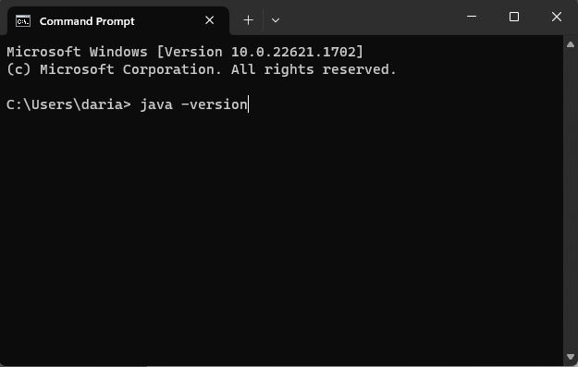Then just type in java -version:

Hit Enter, and you will see something similar to the screenshot below if you already have JRE installed:

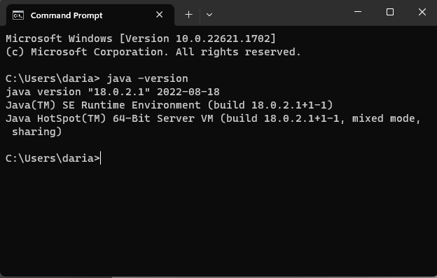

If you don’t have a JRE installed, follow the steps below.

Navigate to the following link:

https://www.oracle.com/java/technologies/downloads/#jdk20-windows.

Now, underneath “JDK Development Kit 20.0.1 downloads”, make sure you select the “Windows” tab and click the link to download the “x64 Installer”:

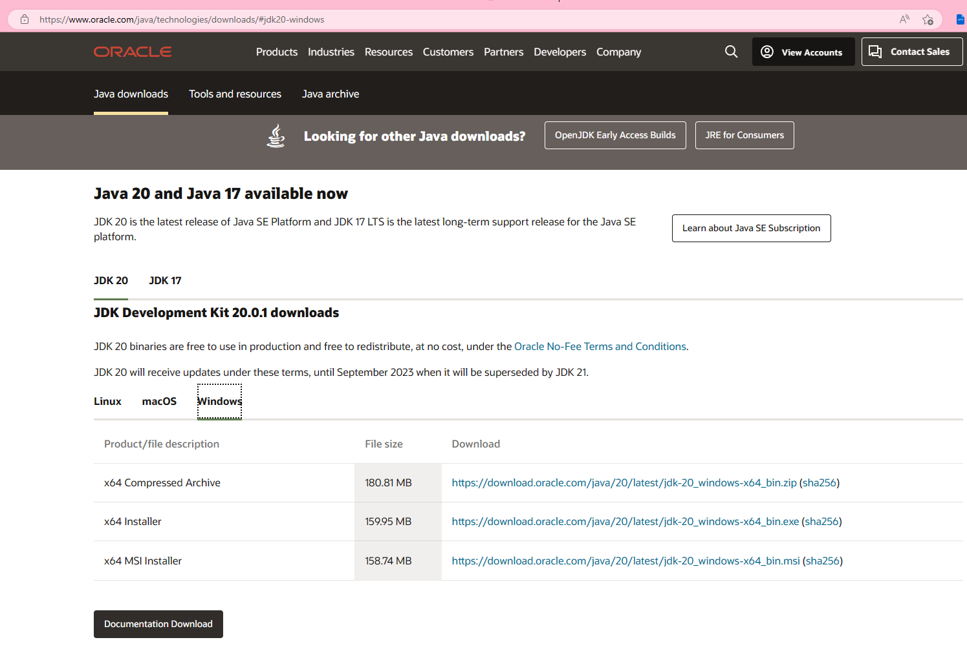

Give the file a little time to download. Once it’s downloaded, navigate to your Downloads folder, and double click the file:

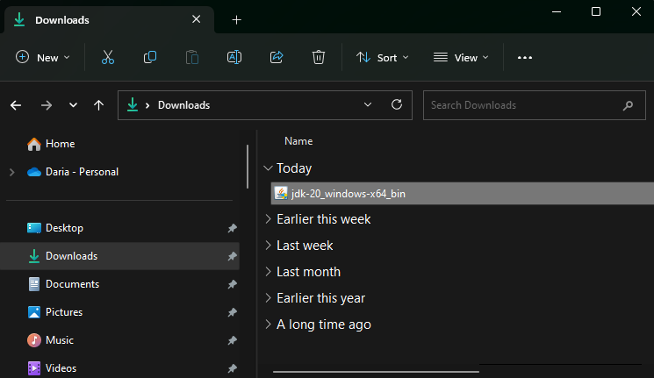

If you asked to allow the app to make changes to your device, press “Yes”.

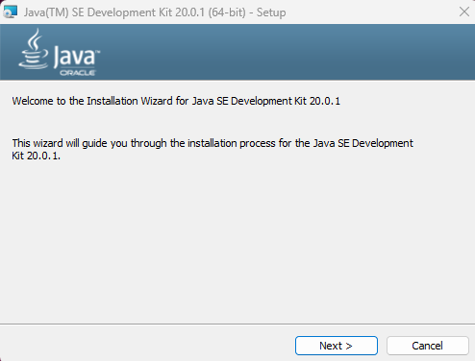You will then be taken through the Setup process. The following window should appear:

Click “Next”.

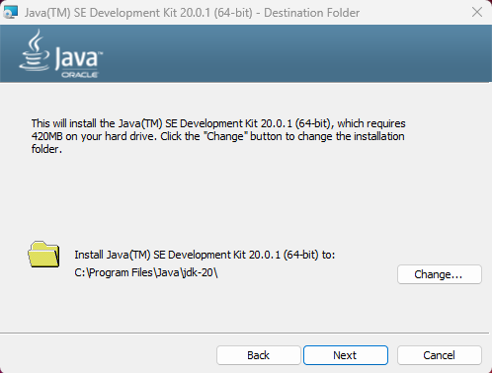You are then informed the software requires a certain amount of memory and where the installation folder will be stored. It is best to leave this as it is and click “Next”:

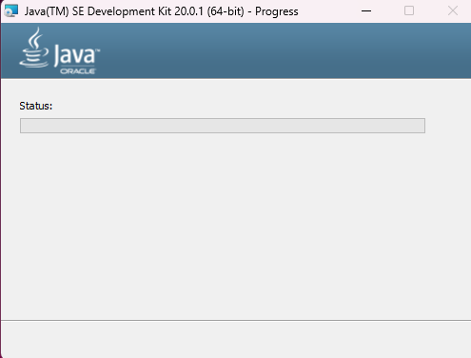After clicking “Next”, let it do its thing:

Once installation is complete, you will see a success message. Just click “Close”:

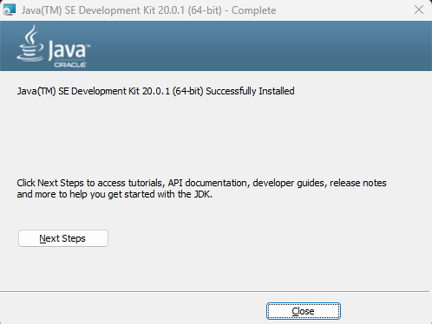

If you now open a Command Prompt window and type in java -version, you should see something like this:

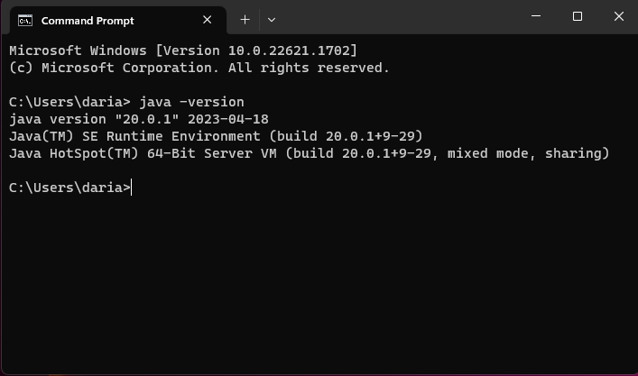

Great! Now you have the tools you need to start using your brand spanking new case management system!

# Using Your New System

Back at the start of this project, you told us that you would like a case management system that allows your firm to control their workload more efficiently. We’ve built your new case management system with user experience in mind, but we’ve also prioritised the security and quality of your data. This is why you might find some functionality missing in this version: we understand how important it is to keep sensitive and confidential information safe and wanted to concentrate our efforts on implementing your software well, rather than quickly.

With any new versions of your system, you will also receive updated user guides on how to use any new functionality. For now, though, this guide will help you to get started with your new system.

# Logging In

Logging in to your new system is very simple. If you’d rather see a video of logging in, you can find one in the PowerPoint file included in your User Pack. If you’re happy following written instructions, follow the steps below. Your employer should have issued you with your username and password. You can reset your password if you wish – we would strongly advise you do this for security – and there are instructions included in this document to show you how to do this. Alternatively, your PowerPoint file also includes a clip on how to reset your password.

Firstly, you have to start the system. So navigate your way to wherever the User Pack folder you have been issued with is stored:

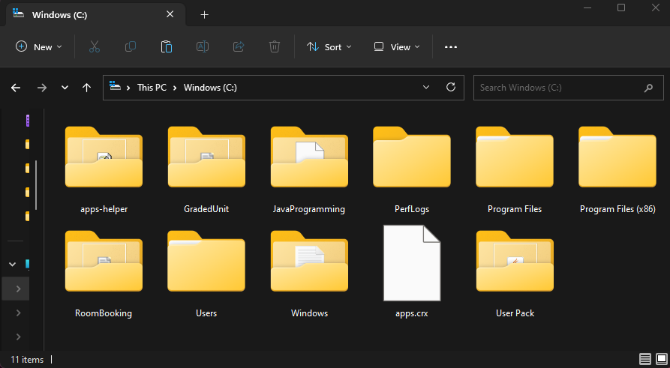

The folder

Inside that folder you should see a file named “McRae & Dick Case Management System”. Double click this:

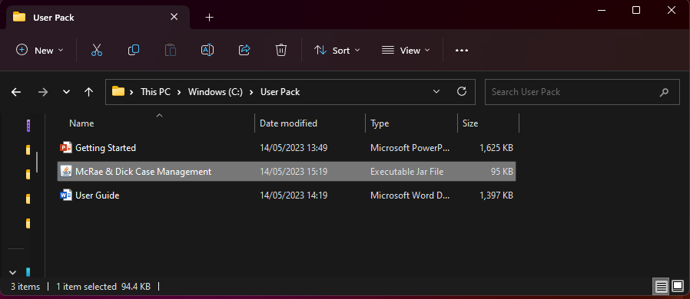

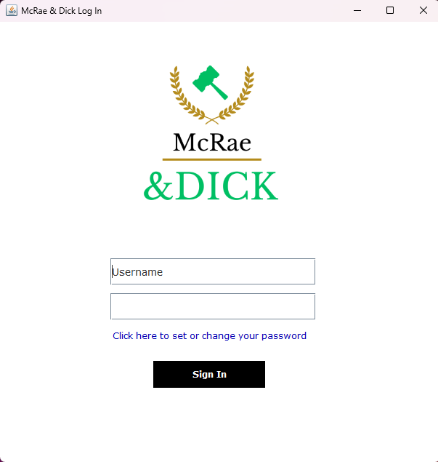You should be presented with your Log In screen:

To log in to the system, enter the username you have been provided with in the “Username” box. Enter the password you have been provided with in the box underneath. If you hover over these boxes with your mouse, you will see there are helpful hints to ensure you enter the right details in the right places.

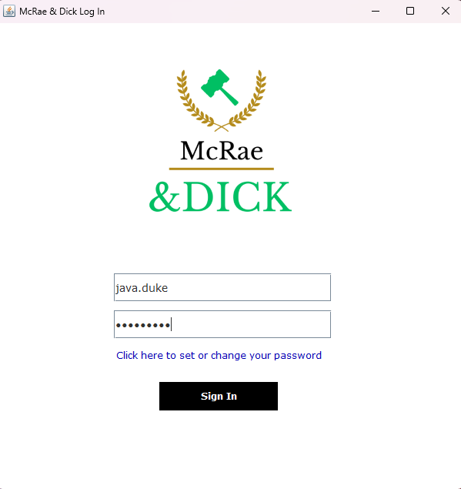

Now, just press “Sign In”. If you have entered your log in details correctly, you should be presented with the Home screen:

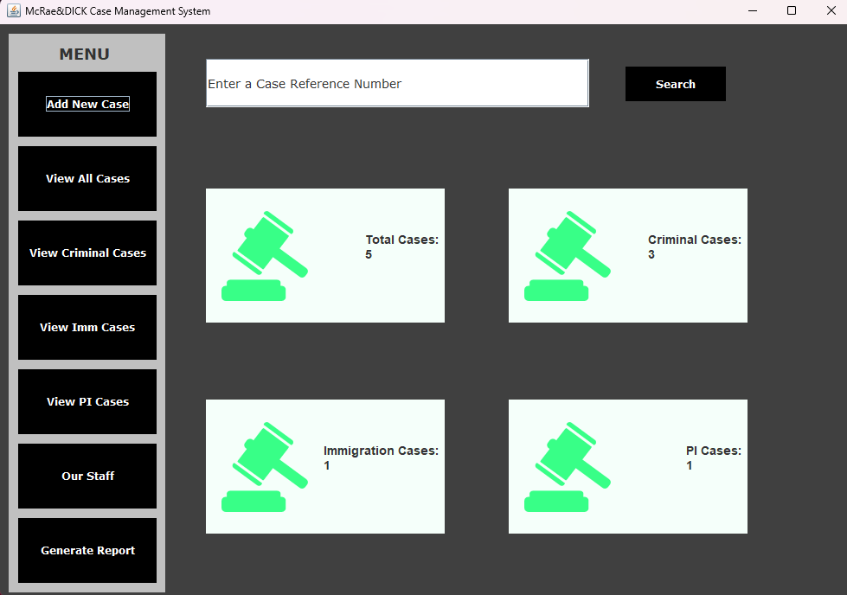

And that’s you logged in! If you want to learn how to reset your password, skip to the section Resetting Your Password.

# Resetting Your Password

Resetting your password regularly is always advised to protect your firm from vicious cyber‑attacks. We’ve taken steps to keep your log in details secure, but you can never be too safe! We hope you find resetting your password easy – the steps below show how to do this.

When you start the system and see the Log In window, click on the blue link that says “Click here to set or change your password”:

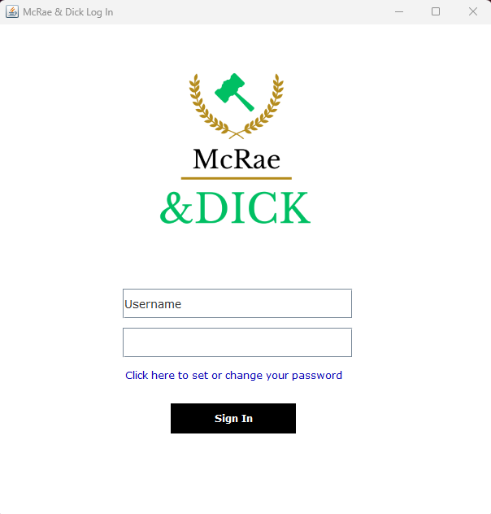

Click this link to change your password.

This will present you with another window:

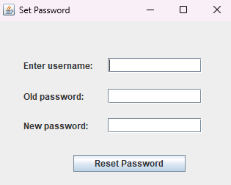

All you have to do is enter your username where indicated, enter your old (current) password where indicated, and finally enter your new password where indicated.

Something to note: we know you want to keep your data secure, so your new password must conform to the following rules:

* 12 characters;
* must include special characters;
* 1 number; and
* and 1 uppercase character.

If you enter a new password that doesn’t meet the criteria above, you’ll see an error message!

Once you’ve entered acceptable details and pressed “Reset Password”, you should see a confirmation message telling you you’ve successfully changed your password:

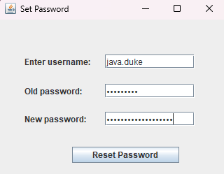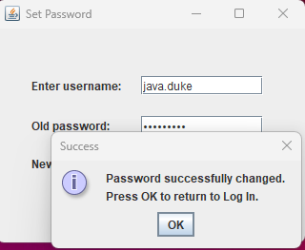

Now, just press “OK” and you will be returned to the Log In window. You are now ready to log in using your new password.

# Adding a New Case

What good would your new system be if you couldn’t add a new Case?

After you’ve logged in, you’ll see there’s a navigation menu on the left hand side. Press the “Add New Case” button and you should be presented with a new window:

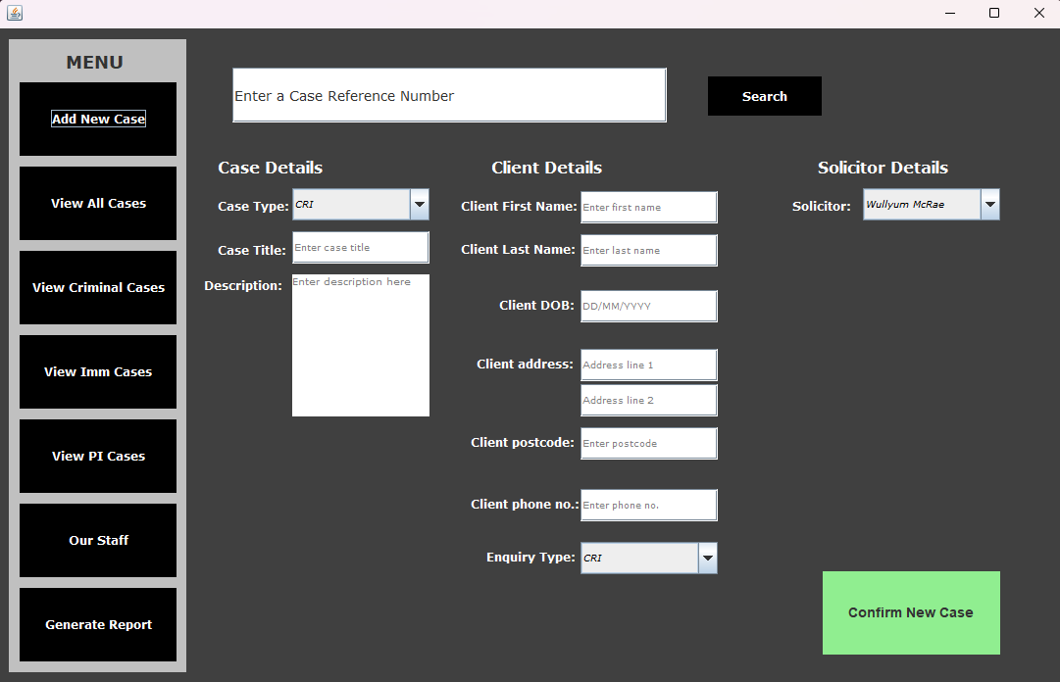

This is where you will enter all the relevant details of your new Case. If you hover your mouse over any of the fields, you’ll find helpful hints that inform you what the system expects to receive. For example, if you hover over the Client DOB field, you’ll see there’s a hint that tells you to enter the date of birth in the format DD/MM/YYYY:

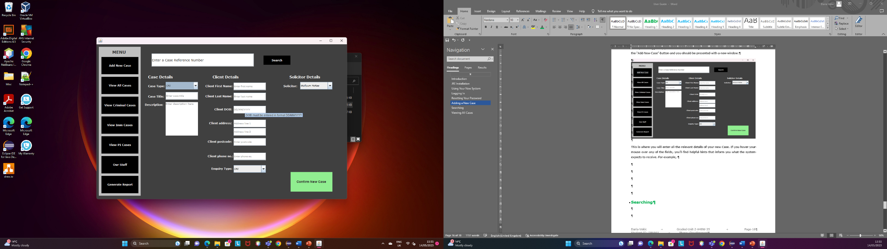

All you have to do is enter all the relevant details of the new Case. Have a look at the screenshot below for an example.

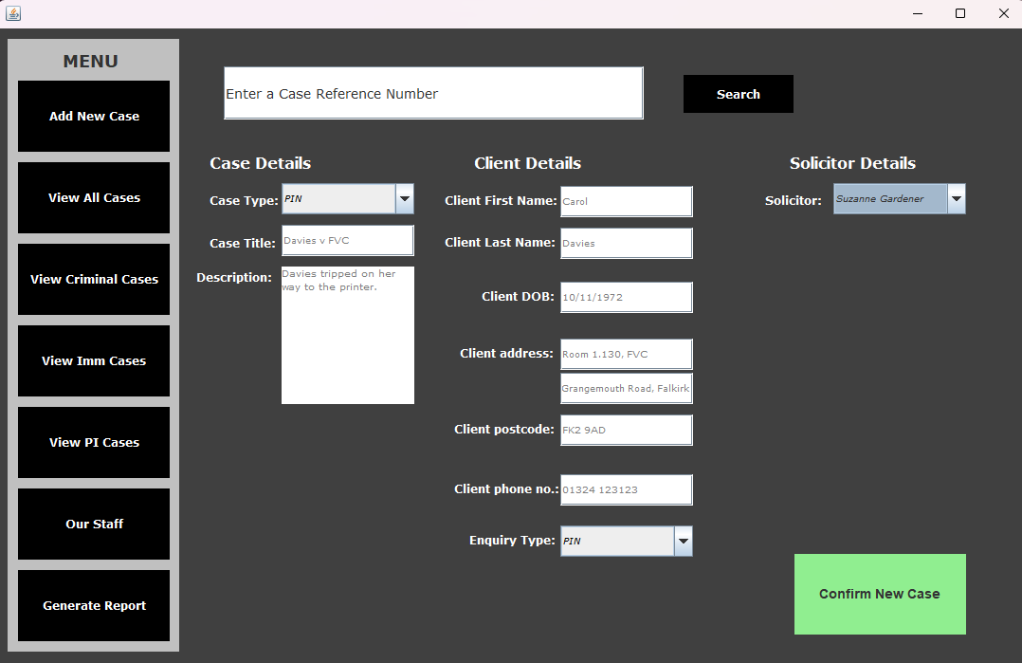

After you’ve filled this form in, just click “Confirm New Case”. You should be presented with a confirmation message that indicates the new Case’s reference number:

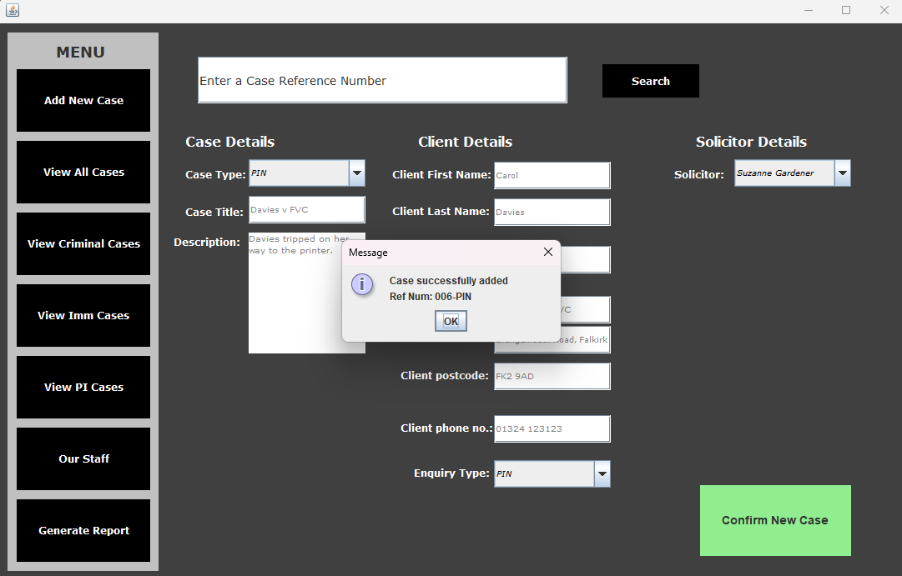

Press “OK” and the form will reset ready for the next Case to be added.

There’s also a video clip of a new Case being added for you to watch in your PowerPoint file.

# Searching

We’ve just added a new Case, great!

Now, you can search for that Case using the case reference number. There’s a search bar present at the top of every window – you’ll see it has text that reads “Enter a Case Reference Number” with a “Search” button right next to it.

In this, all you have to do is enter the reference number of the Case you want to view and then hit “Search”.

Below you can see I’ve performed a search for the Case I’ve just added:

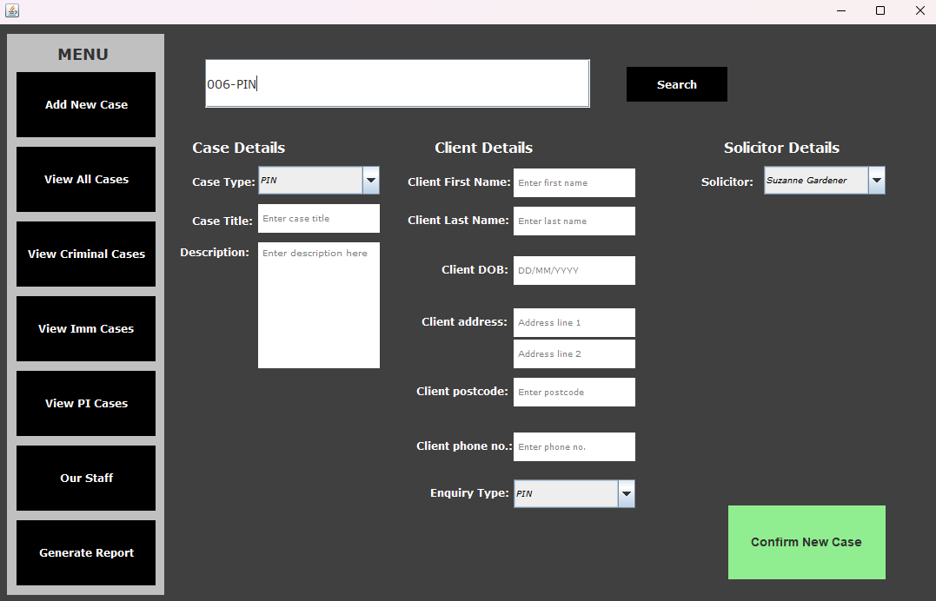

And after I’ve hit “Search”, the details of that specific Case are displayed in a new window:

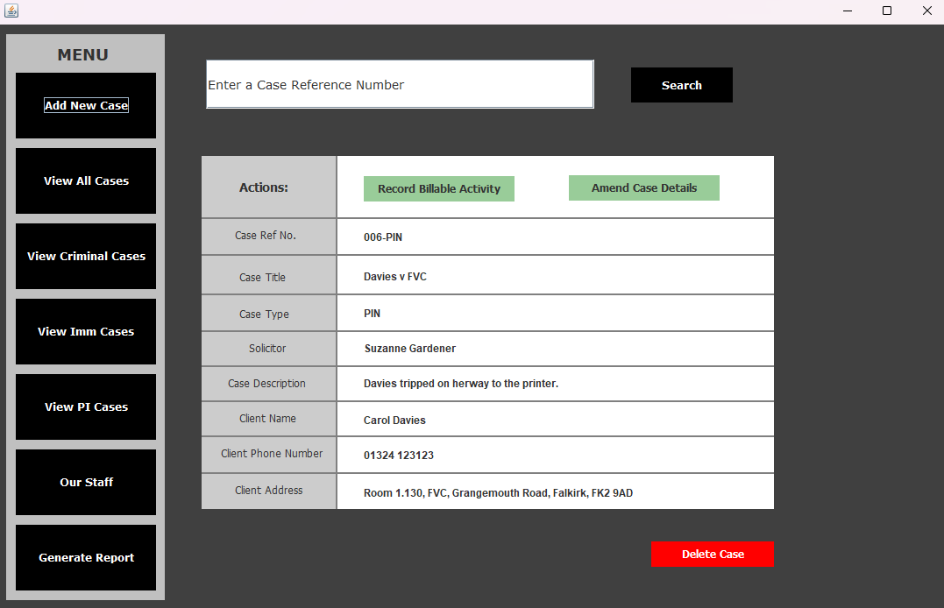

# Viewing All Cases

We all have our blonde moments from time to time, and we don’t expect you to remember every single Case number off the top of your head.

Instead of searching for a specific Case, try pressing the “View All Cases” button in the navigation panel. It’s immediately underneath the “Add New Case” button we used earlier to add a new Case to the system.

The entire Caseload in your system is displayed in a new window, with all the case reference numbers and other details displayed in a structured manner:

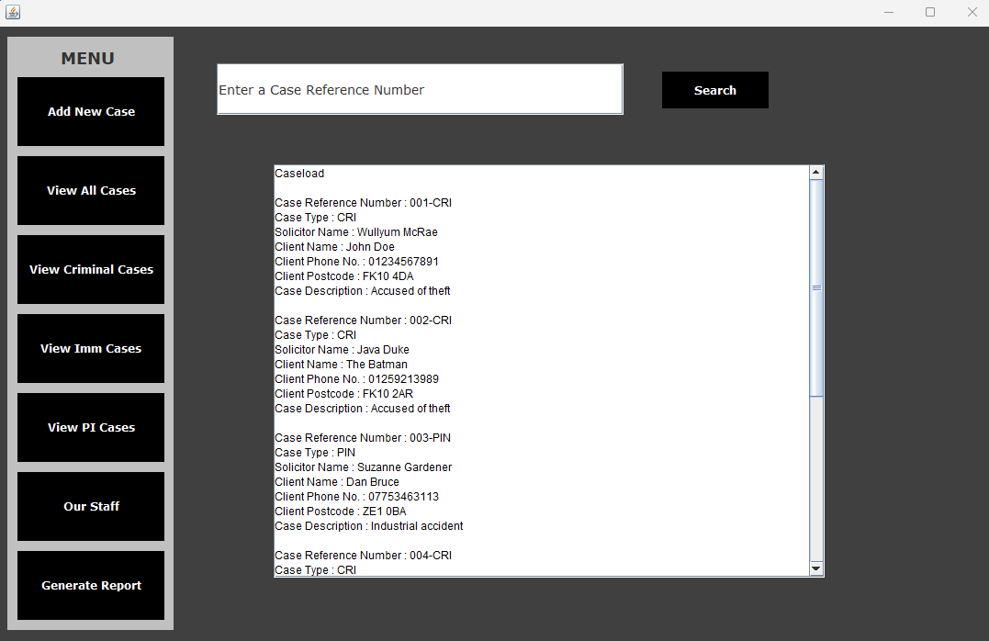

You’ll see at the bottom of the Caseload list is the Case we’ve just added:

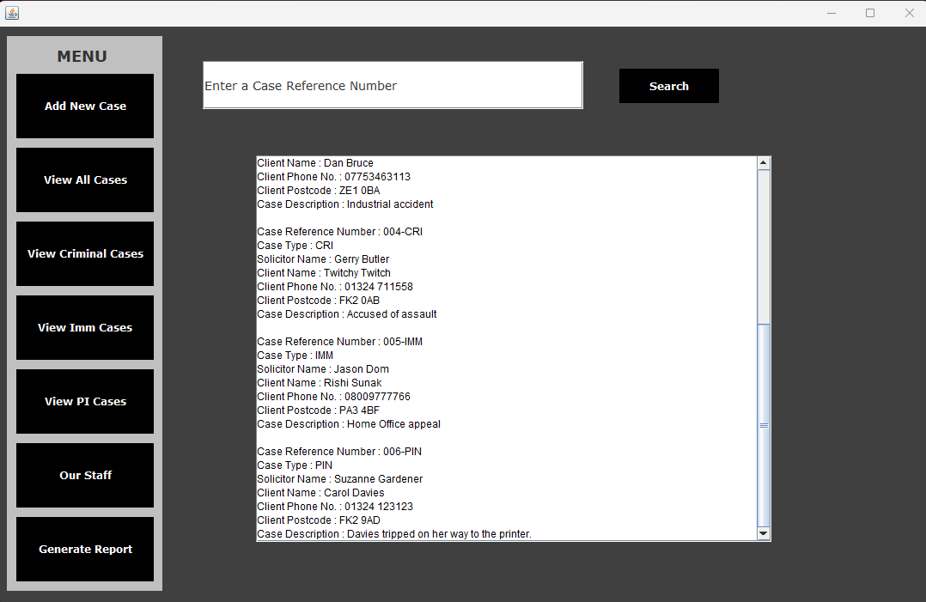

The Case we’ve just added